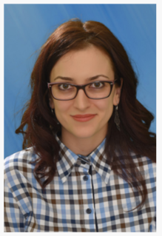
Marica Simić

viši asistent
Email adresa: |  | micic.eng@gmail.com

Bibliografija

Knjige

-
Radovi u časopisima
• Đ. Mirković, M. Simić LANGUAGE BARRIERS COMPLEXITY AND THEIR IMPLICATIONS WITH FATAL CONSEQUENCES IN AVIATION Knowledge International Journal Vol. 30.5, pp. 1131-1135, March 2019
• Đ. Mirković, M. Šmelcerović, M. Simić, J. Abula, T. Vasiljević-Stokić CONCEPT OF WRITING AS ONE OF LANGUAGE SKILLS Knowledge International Journal Vol. 26.3, pp. 781-785, Sept. 2018
• Đ. Mirković, M. Šmelcerović, M. Simić, J. Abula INSIGHT INTO THE MOST SIGNIFICANT CLUES OF IELTS Knowledge International Journal Vol. 23.5, pp 1395-1399, May 2018

Radovi na konferencijama
• M. Simić, Đ. Mirković BOOK REPORTS IN LEARNING ENGLISH AS A SECOND LANGUAGE Prozor u svijet obrazovanja, nauke i mladih, pp. 375-384, April 2019.
• M. Simić KNJIŽEVNOST ZA DJECU U NASTAVI STRANOG JEZIKA Nauka i nastavna praksa, Nov. 2017.
• M. Mićić OSUDA DRUŠTVA U ROMANU SKERLETNO SLOVO Nauka i nastavna praksa, Nov. 2015.

